Experiment 1: JSX and Virtual DOM
App.js
import React, { useState } from "react";
function App() {
const [count, setCount] = useState(0);
return (
<div>
<h1>JSX and Virtual DOM Demo</h1>
<p>Count: {count}</p>
<button onClick={() => setCount(count + 1)}>
Increment
</button>
</div>
);
}
export default App;
Output
- Displays count value.
- Count updates instantly when button is clicked.
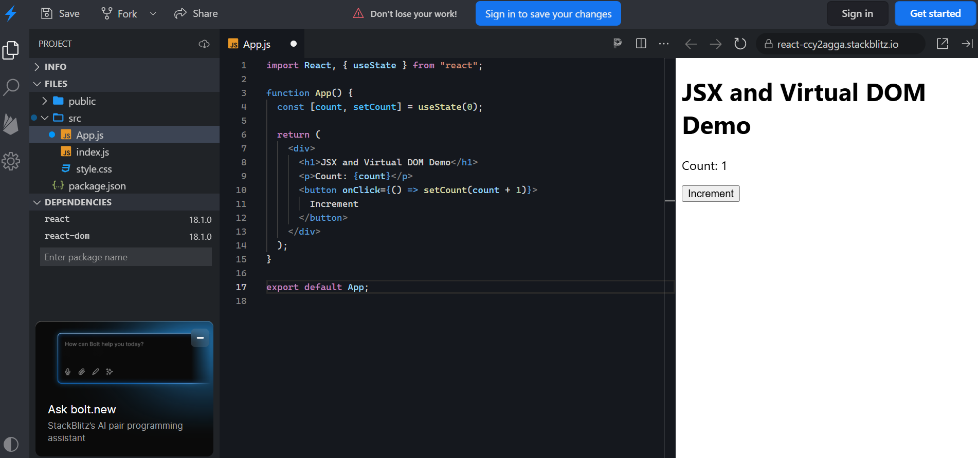
Experiment 1: React Application to Demonstrate JSX and Virtual DOM
Aim
- To understand the use of JSX in React.
- To demonstrate how the Virtual DOM updates UI efficiently.
Procedure
- Create a React application using create-react-app.
- Create components using JSX syntax.
- Display dynamic data using state and props.
- Observe UI updates when state changes.
Input
- User clicks a button to change state.
- Text or data entered by the user.
Output
- JSX-rendered content displayed in the browser.
- Updated UI without full page reload using Virtual DOM.
Experiment 1: Demonstrate JSX and Virtual DOM
Aim
To build a React application that demonstrates JSX and Virtual DOM concepts.
Software Requirements
- Node.js
- React.js
- Visual Studio Code
- Web Browser
Theory
JSX (JavaScript XML) allows writing HTML-like syntax within JavaScript. React uses a Virtual DOM to efficiently update only the changed parts of the user interface, improving performance.
Algorithm
- Create a React application.
- Create a state variable using useState.
- Display the state value using JSX.
- Add a button to update the state.
- Observe the UI update through Virtual DOM.
Program
(Experiment 1 code here.)
Sample Input
Click the Increment button.
Sample Output
JSX and Virtual DOM Demo
Count: 0
[Increment]
After Click:
Count: 1
Result
Thus, a React application demonstrating JSX and Virtual DOM was developed and executed successfully.

